Literacy-Adapted Cognitive-Behavioral Treatment Manual and Patient Workbook for Patients with Chronic Pain

Client Workbook
Patient Outlines
Patient Handouts
Patient Worksheets

Adapted for 4-6 grade literacy level for the following NIH-supported RCT:
Cognitive-Behavioral Pain Trial Among Rural Minorities and Non-minorities
NR010112 (Thorn, P.I.)

Melissa C. Kuhajda, Ph.D.
Beverly E. Thorn, Ph.D.
Melissa Day, M.A.
Chalanda Cabbil, B.A.

September, 2010

Literacy-adapted manual from the following source:
Thorn, B.E. (2004). Cognitive Therapy for Chronic Pain: A Step-by-Step Guide, New York: Guilford Publications

http://www.guilford.com/cgi-bin/cartscript.cgi?page=pr/thorn.htm&dir=pp/acpp&cart_id=230964.27905

Contact Author: Beverly Thorn
Bthorn@ua.edu

TABLE OF CONTENTS

Session 1: Welcome to Group, We are Happy You are Here
Client Outline 3-10
Client Worksheets 11-12

Session 2: Stress Judging Coping Model of Pain, Naming Automatic Thoughts
Client Outline 13-20
Client Handout 21
Client Worksheets 22-23

Session 3: Judging Automatic Thoughts
Client Outline 24-29
Client Worksheets 30-31

Session 4: Challenge Automatic Thoughts, Create Alternative Thoughts
Client Outline 32-36
Client Worksheets 37-38

Session 5: Should Beliefs
Client Outline 39-45
Client Worksheets 46-49

Session 6: Core Beliefs
Client Outline 50-57
Client Worksheets 58-61

Session 7: Coping Statements, Relaxation
Client Outline 62-68
Client Handout 69

Session 8: Express Yourself
Client Outline 70-73
Client Handout 74

Session 9: Assertive Communication
Client Outline 75-81
Client Handout 82-84
Client Worksheets 85-88

Session 10: Graduation Session
Client Outline 89-95
Client Handout 96-99

Appendix I: Sample Completion Certificate (Template) 100

Session 1

Welcome to Group
We are Happy You are Here

Coping with Chronic Pain Group
- You will learn a lot about pain.

- You will learn new skills for coping with your pain.

- You will learn how your thoughts affect your feelings and your behavior.

- You will learn how your thoughts, feelings, and behavior affect your pain.

- You will learn how practicing relaxation helps you cope with pain.

Privacy Rules

- Your leaders will not talk about members of your group to anyone outside the group.

- We ask you not to talk about members of your group to anyone outside the group.

Special Jobs for Group Leaders

- Teach skills to help you work out problems

- Do team work by working together with you

Special Jobs for Group Members

- Show up for group each week. What you say in group is important.

- Be active. Group works best when you take part.

- Share only what you are comfortable sharing.

- Practice at home what you learn in group.

- Share with the group what skills help you and what skills do not help you.

Tell the Group about You

- What is your name?

- What do you like to do?

- Tell the group about your pain.

How are Stress and Pain Related?
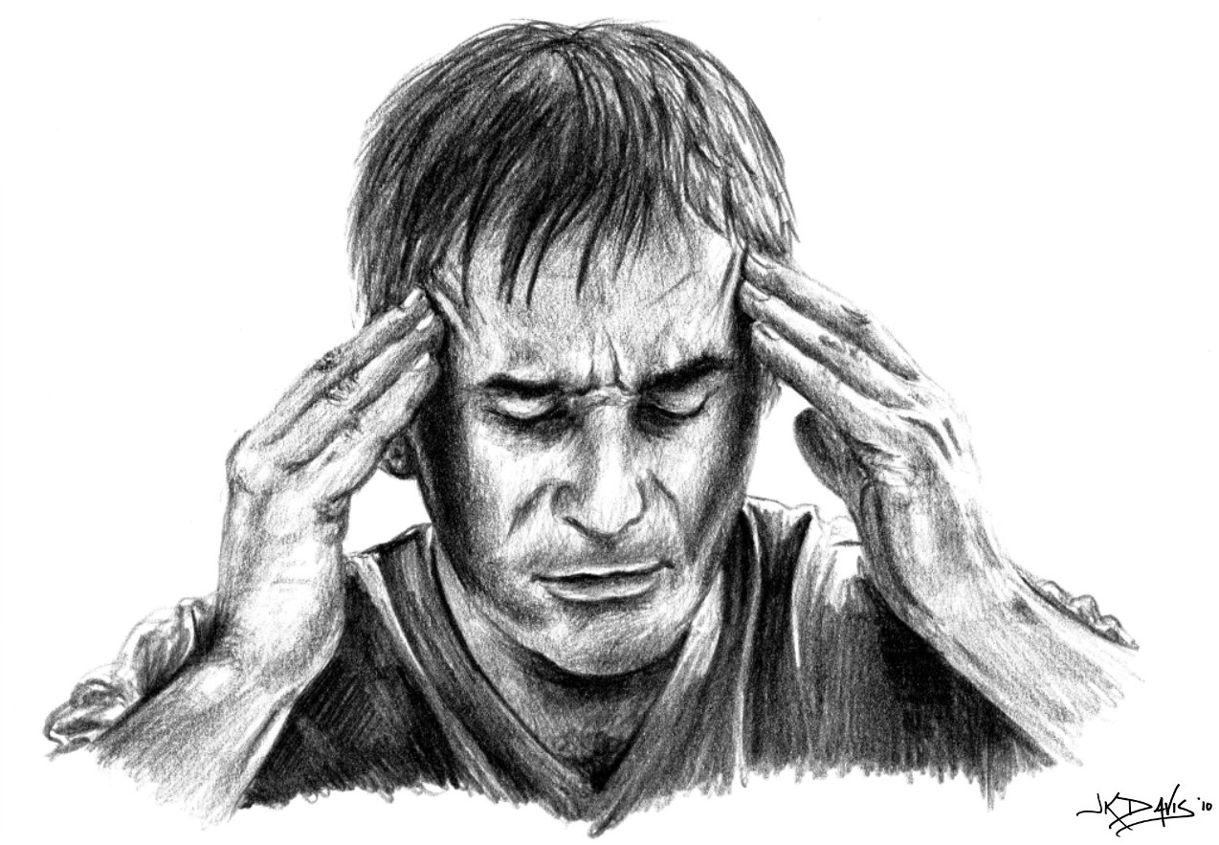

- Pain makes stress. Stress makes pain worse.

    - Coping with stress in a good way makes pain better.

- What is stress anyway?

- Stress is how your body deals with change.

- What is the Stress Response?

- The Stress Response happens when you think you cannot cope with something.

- This something you are trying to cope with could be a stressful event, strong emotion, pain, or physical injury.

The Stress Response has 3 parts.
- Biological – Your Body

  - Blood pressure goes up.

  - Muscles get tight.

  - Body makes more stress hormones.

  - Immune system stops working right.

- Emotional – Your Feelings

  - Nervous

  - Sadness

  - Anger

  - Shame

- Cognitive – Your Thoughts

- You may have trouble making decisions.

- Thoughts and pictures in your mind may become confused.

- Anything that causes the Stress Response is a stressor.

- Pain is a stressor.

- Chronic pain can be a big stressor.
- Chronic pain can lead to the Stress Response.

- Body changes, feelings, thoughts, and actions can be stressors.

- Our stressors do not have to be about our pain.
- Stressors can be about other problems in our life.
- Any stressor can make our pain worse.

How are Stress and Judging Related?

- Any event, feeling, or body change can be stressful. We might think I cannot cope with this stressful feeling.

- It is not stressful when we think I can relax. I can cope.

- How we think about or judge a stressful event is more important than the event itself.

- We can judge stressful events as threats, losses, or challenges.

- For example, maybe your son or daughter is looking for a job. He or she might think about this event as a

  - Threat I’m scared! What will people think about me?
  - Loss I won’t find a job!
  - Challenge I will do my best!
Learning Activity How are my Stress and Pain Related?
- We will do this together in group.

Take-Home Daily Learning Activity
How are my Stress and Pain Related?
- You will write on your worksheet each day at home just like we did in group today.

- Write about one stressful situation.

- Write how you think about or judge this situation.

Is it a threat? Is it a loss? Is it a challenge?

- Write how this stressful situation makes you feel.

- Write how this stressful situation makes your body feel.

- Write how this stressful situation makes you act or behave.

- Write how this stressful event makes you think.

What thoughts or pictures are in my mind?

Bring your Take-Home Daily Learning Activity to the next group meeting. Be ready to talk about what you learn.

Summary
- The Stress Response has 3 parts.

- Biological – body changes in blood pressure and muscle tension

- Emotional – sad or nervous

- Cognitive – thoughts and pictures in your mind may become confused

- Chronic pain is a stressor.

- Any stressor—pain or no pain—can make our pain worse!

- The way we think about or judge our stress affects what we think, feel, and do about our stress.

Session 1 Worksheet

How are Stress and Pain Related?

Stressful  Situation | How do I judge this stressful situation?  A Threat?  A Loss? or  A Challenge? | How does this  make me feel?  emotion | How does this make my body feel?  physical | How does this make me act?  behavior | How does this make me think?  thought  or picture in my mind
Looking for a job | Threat  Loss  Challenge | Anxious  Scared  Nervous  Sad  Depressed  Flat  Excited  Determined | Increased heart rate Increased blood pressure  Shortness of breath  Increase in muscle tension & pain  Tired  Body aches and pains  Energized  Relaxed | Pacing around home  Went to bed  Checking job advertisements, going for an interview | “I’m scared, what will people think about me?”  “I won’t find a job!”  “I will do my best!”

Session 1 Worksheet

How are Stress and Pain Related?

Stressful  Situation | How do I judge this stressful situation?  A Threat?  A Loss? or  A Challenge? | How does this  make me feel?  emotion | How does this make my body feel?  physical | How does this make me act?  behavior | How does this make me think?  thought  or picture in my mind

Session 2

Stress Judging Coping Model of Pain
Naming Automatic Thoughts

Session 2 Goals

- Learn Ideas about How Pain Works

- Learn the Stress Judging Coping Model of Pain

- Learn to name Negative Automatic Thoughts

Review from Last Session

- We respond to stress in three basic ways

  - Biological-Your Body

    - Blood pressure goes up
    - Muscles get tight

  - Emotional-Your Feelings

    - Sad
    - Anger
    - Nervous

  - Cognitive-Your Thoughts

    - Trouble making decisions
    - Thoughts and pictures in your mind may become confused

- Chronic pain is a stressor.

- Some stressors are not about pain, but any stressor can make our pain worse.
- Thoughts or judgments about your stress affect what you think, feel and do.

  - Is my stress a threat?

  - Is my stress a loss?

  - Is my stress a challenge?

Learning Activity from Last Session

- Share one stressful situation from your worksheet with the group.

- How did you judge this stressful situation?

    - Threat?
    - Loss?
    - Challenge?

- How did your judgment about your stressful situation

    - Make you feel? Emotions
    - Make your body feel? Physical
    - Make you act? Behavior
    - Make you think? Thoughts or Pictures in your Mind

Ideas about How Pain Works

- The Direct Path is one of the early ideas about pain.
  - The idea is that a painful body injury has a direct connection to the brain.
  - The idea is that people with a lot of pain must have a lot of damage in their body.
  - This Direct Path Idea is wrong.
- Gate Control is a newer idea about pain.

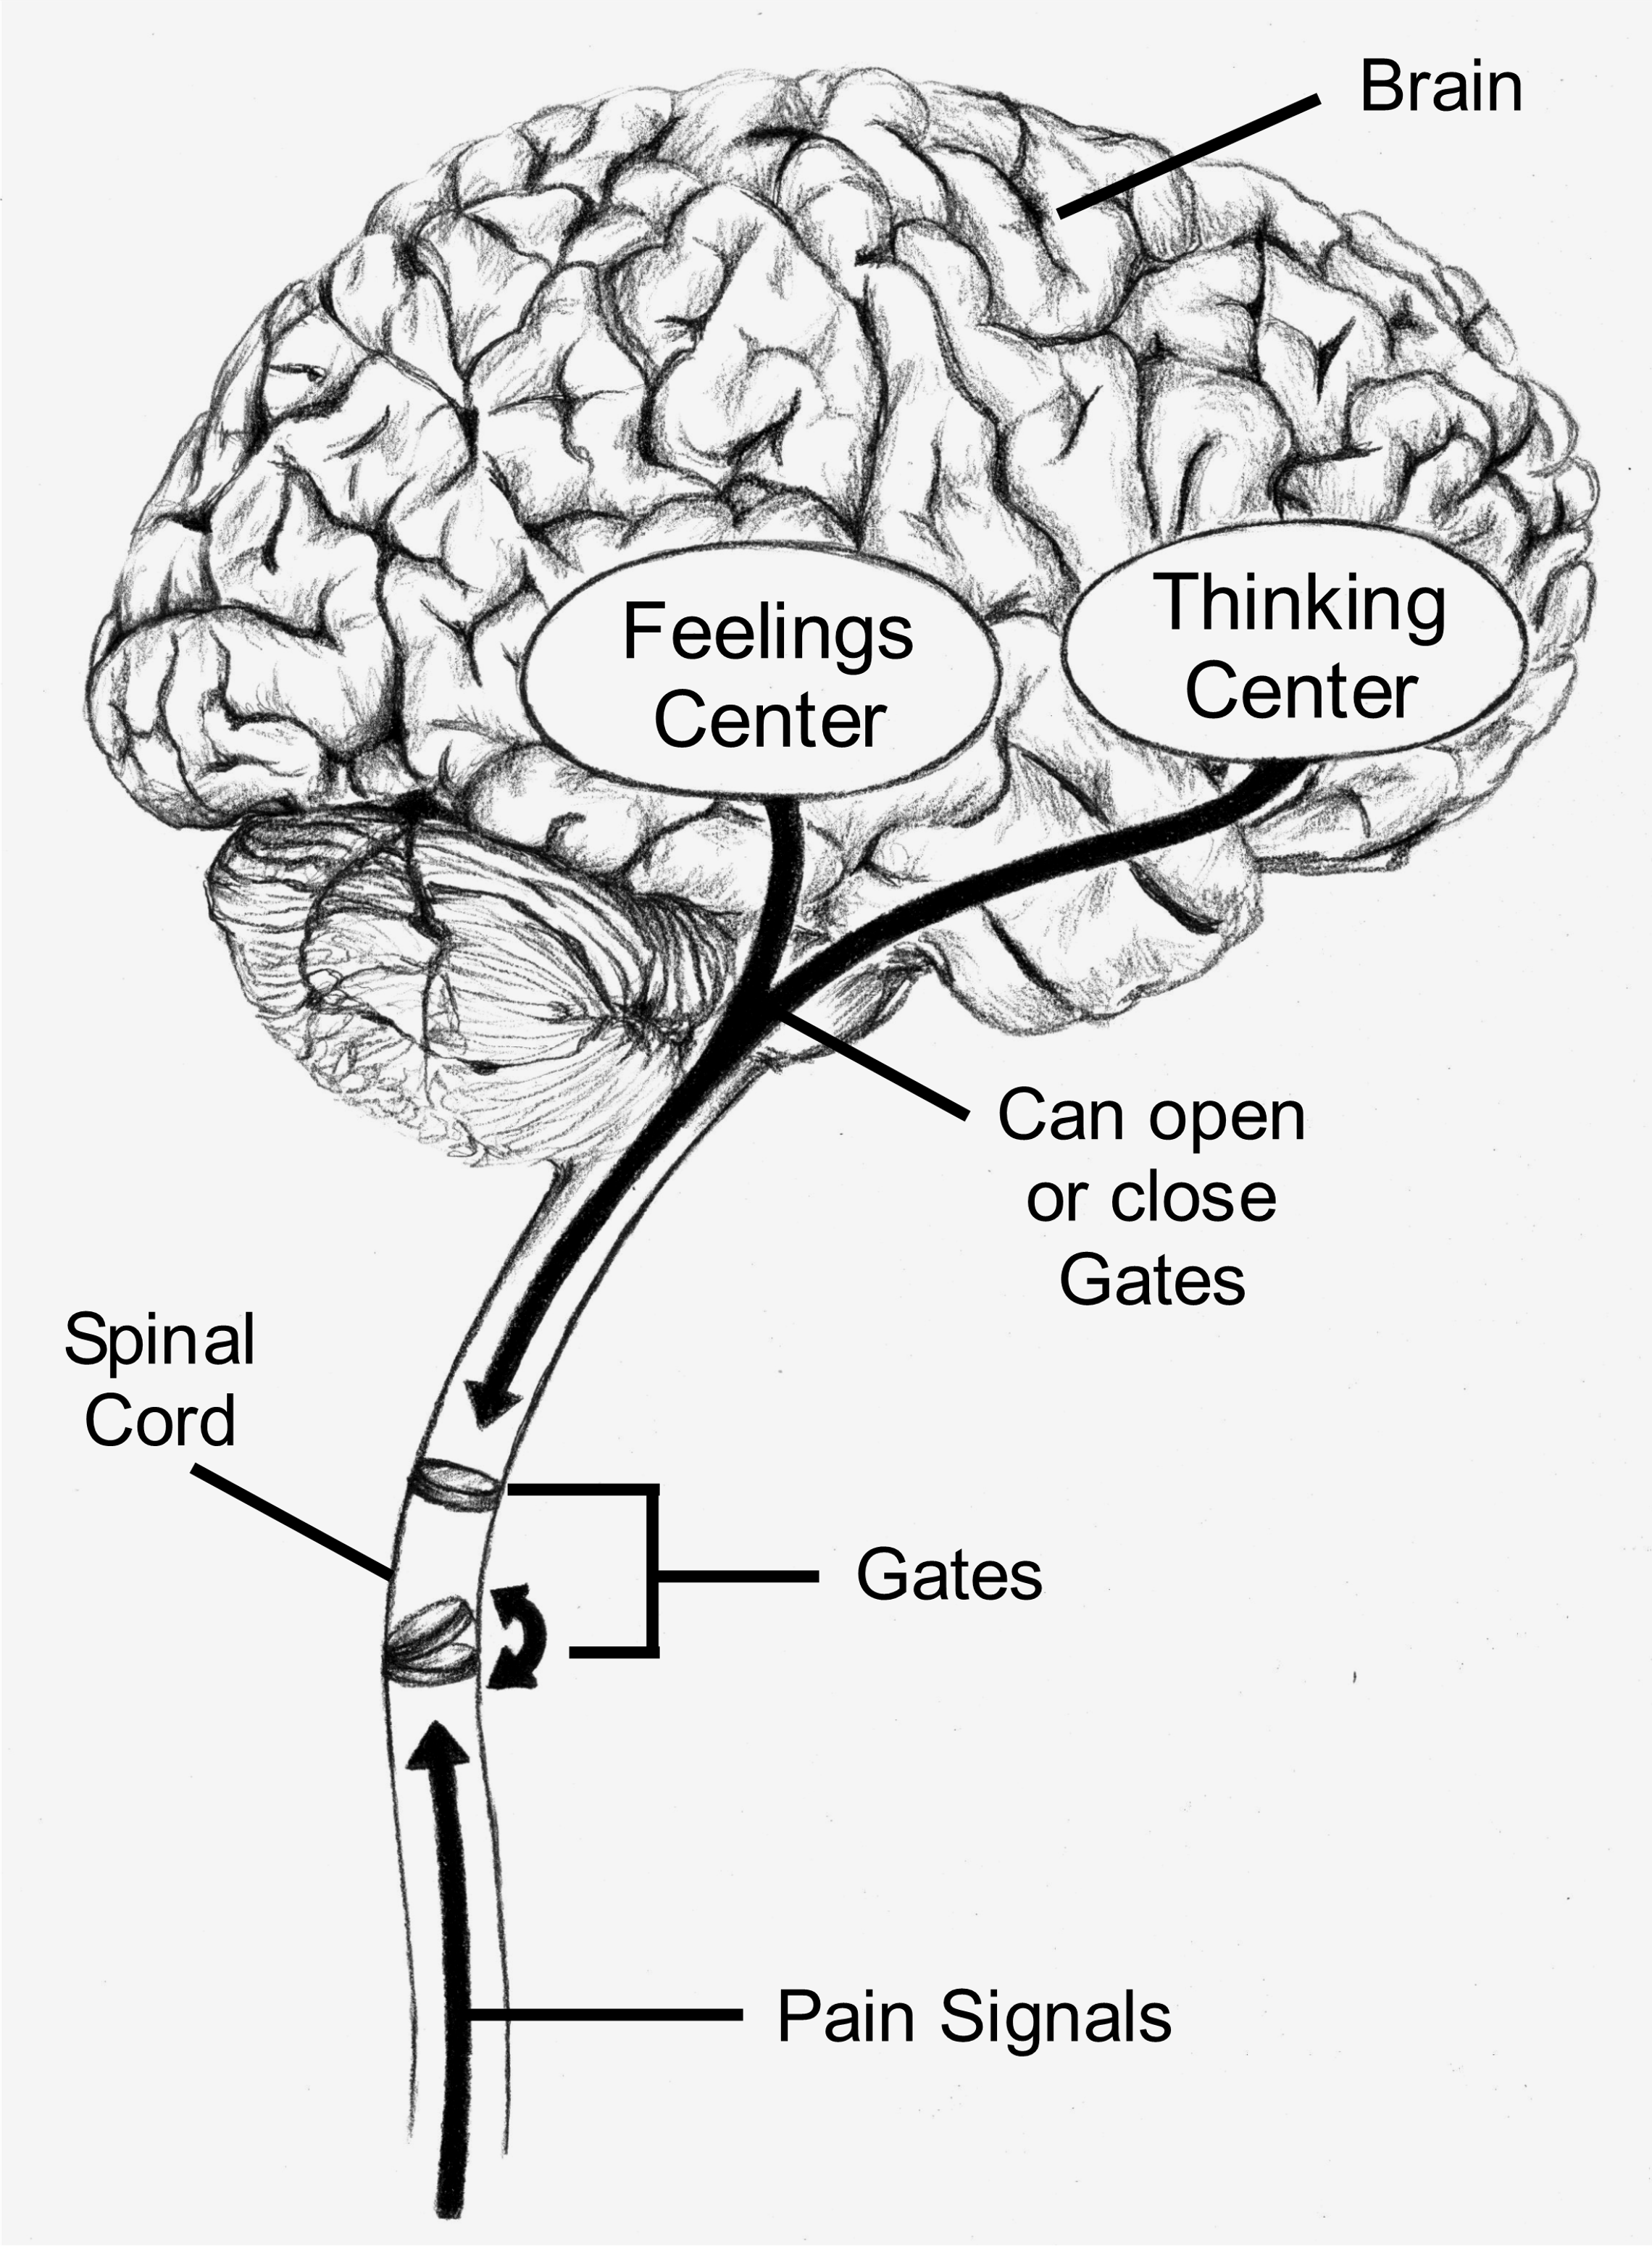

- Opening the gate in the spinal cord lets more pain signals through to the brain.

    - Things that open the gate wide
      - No exercise Sitting Not doing much
      - Negative mood
      - Negative and distorted thoughts
      - Pain medicine opens the gate sometimes
        - When you take it for a long time or
        - When you take more than the doctor prescribes

- Closing the gate in the spinal cord is good. Not as many pain signals get to the brain.

    - Things that close the gate
      - Being active
      - Feeling positive
      - Thinking positive—having hope
      - Pacing your activities
      - Pain medicine closes the gate sometimes
        - When you take it for a short time and
        - When you use it the way the doctor says

- Thoughts and Feelings can open or close the gate.
  - Brain scans taken when people are in pain show brain activity in Thought areas and Feeling areas.
  - These Thought and Feeling areas of the brain affect how the brain deals with pain.
  - These Thought and Feeling areas of the brain affect how we deal with pain.

Stress Judging Coping Model of Pain
- The Stress Judging Coping Model of Pain explains how our thoughts affect
    - Our pain
    - Our feelings
    - Our behavior
    - How our bodies feel
- 4 Main Types of Thoughts
  - Judgments about stressful situations
  - Automatic Thoughts
  - Beliefs
  - Coping Thoughts
- Often thoughts about our pain or stress are automatic.
    - We are not aware of these thoughts.
    - We can learn to be aware of our Automatic Thoughts.

Naming Automatic Thoughts
- Automatic thoughts are judgments about our stress.
- When we judge stressful situations as a threat or a loss, we are having a negative automatic thought.
  - Negative Automatic Thoughts
    - Make you pay too much attention to your pain
    - Make your pain seem worse
    - Cause your view about pain to be twisted or distorted
    - Make it hard to think about anything but pain
    - Make you believe you are helpless
    - Make you believe you have no control

Negative Thinking Handout
When you read the Negative Thinking Handout you might say
I think like that sometimes.
Naming your negative automatic thoughts is the first step to changing them.

Learning Activity Automatic Thoughts Worksheet 1 ATW 1
- We will do this together in group.

Take-Home Daily Learning Activity
Automatic Thoughts Worksheet 1 ATW 1
- Each day use the worksheet like we did in the group.
  - Write about one stressful situation.
  - Write about changes you notice in your feelings.
  - Write about changes you notice in your body.
  - Write about changes you notice in your behavior.
  - Write the automatic thoughts or pictures in your mind near the time of
the stressful situation.
    - Hint - Words like always and never are red flag words. Pay close attention to these words. Automatic Thoughts with always or never are mostly negative.
  - Rate how much you believe each of your automatic thoughts or
pictures in your mind. 25% or 50% or 75% or 100%
    - Rating helps you know which automatic thoughts have a strong hold on your feelings, body, and behavior.
- It is not important to move through the worksheet in any certain order. Start where you are and work from there.
  - At first you might notice changes in your behavior. Write these changes under Behavior. Then you can backtrack and fill in
    - The stressful situation
    - Your emotions
    - Your body
    - Your automatic thought.

Bring your Take-Home Daily Learning Activity to the next group meeting. Be ready to talk about what you learn.

Summary

- The brain controls how we deal with pain. The Gate Control idea shows how our thoughts and feelings can open or close the gate. This means that our Thoughts and Feelings are key to learning how to manage our pain.

- There are 4 kinds of thoughts in the Stress Judging Coping Model of Pain.
- Judgments about stressful situations
- Automatic Thoughts
- Beliefs
- Coping Thoughts

- How Thoughts affect our Pain
  - Automatic thoughts come from judgments about stressful situations.
- You may not be aware of your automatic thoughts.
  - Negative automatic thoughts are harmful.
- You must become aware of your negative Automatic Thoughts to change them.

Session 2 Handout

Examples of Negative Thinking
Category | Definition | Example
All or Nothing Thinking | Seeing a situation as all one way or all another way. There is no in between. Also called  “Black or White” Thinking. | “I cannot work anymore, so nothing I do is any good.”
Fortune Telling | Judging your future in a negative way. You do not think about the good things that could happen. | “Oh man, here comes a migraine headache. I know I will have to go get a shot in the ER for sure!”
Not Accepting the Positive | Telling yourself that positive situations do not really count.  You just got lucky. | “I cooked dinner last night, but that is not really good because before that I had not cooked for one month.”
Emotional Reasoning | Feeling something or believing something in a very strong way means that it must be true. | “I can feel my bones grinding together when I move. I don’t care what the physical therapist says, it is not good for me to exercise.”
Labeling | Putting a negative name on everyone in a group. | “All doctors are jerks! They don’t care.”
Magnifying  or  Minimizing | Making the negative seem much worse than it really is.  Making the positive seem not as important as it really is. | “My pain is the worst pain in the whole world! I can’t stand it!”
Mental Filter | Paying too much attention to one negative detail instead of seeing the whole picture. | “My fibromyalgia means that I am not a whole person. I am damaged goods.”
Mind Reading | Believing that you know what other people are thinking. | “My husband thinks that I make my pain seem worse than it really is.”
Overgeneralizing | Because one particular situation is bad, you make it seem like other similar situations will be just as bad. | “I can’t do the work I was trained for anymore, so I won’t be able to go back to work at all.”
Should Statements | Ideas about how the world should be, ought to be or must be, and you hang onto these ideas. | “A good doctor should figure out what’s wrong with me and fix it!”
Personalizing | When you see yourself as the cause of a negative event, but you really had no control over it. | “This pain is a punishment from God for something I did wrong.”

Session 2 Worksheet

Automatic Thoughts Worksheet ATW 1 – Example
Stressful  Situation | Change in  Emotions or Feelings | Change in Body | Change in Behavior | Automatic Thoughts*  or Pictures in your Mind  How much do you believe it?  0% 25% 50% 75% 100%
I found out that the phone company will shut off my phone if I do not pay my bill. | Mad.  Nervous – Frantic. | Tensed up.  Tired. | Slamming things in the kitchen.  Crying – yelling.  Going to bed. | There is nowhere to turn. – 100%  I cannot come up with the money. – 100 %  Why do I even try? – 100%
*Automatic Thoughts often happen right before a change in your emotions-sad-or in your body-muscle tension in neck.

Session 2 Worksheet

Automatic Thoughts Worksheet ATW 1
Stressful  Situation | Change in  Emotions or Feelings | Change in Body | Change in Behavior | Automatic Thoughts*  or Pictures in your Mind  How much do you believe it?  0% 25% 50% 75% 100%
*Automatic Thoughts often happen right before a change in your emotions-sad-or in your body-muscle tension in neck.
Session 3
Judging Automatic Thoughts

Session 3 Goal

- Learn to judge Automatic Thoughts.

Review from Last Session
- The Gate Control Idea of Pain
  - Opening the gate in the spinal cord lets more pain signals through to the brain.
  - Closing the gate in the spinal cord is good. Not as many pain signals get to the brain.
  - Brain activity in the Thought and Feeling areas can cause the gates to open or close.
  - Learning to control our thoughts and feelings can help us cope with pain better.

  - The Stress Judging Coping Model of Pain
  - Our thoughts affect our emotions, body, behavior, and other thoughts.

Automatic thoughts are thoughts or pictures that go through our mind when we have pain or other stress in our lives.

We are not always aware of our automatic thoughts.

- Negative Automatic Thoughts
- Focus our attention on our pain and other stress in our lives
- Make our pain seem worse
- Make everything seem worse
- Lead us to feel helpless
- Automatic thoughts mostly happen right before a change in our emotions, body, or behavior.

Learning Activity from Last Session

Look at your Worksheet ATW 1
- Tell the group about one stressful situation from your worksheet.
- Did you become aware of automatic thoughts about your stressful situation?
- Tell how your automatic thoughts affected your feelings or emotions.
- How did your automatic thoughts affect the physical feelings in your body?
- Tell how your automatic thoughts affected your behavior.
- What else did you learn about naming your automatic thoughts?
- What problems did you have in naming your automatic thoughts?

Learning to Judge Automatic Thoughts
- Some thoughts about our pain or stress are completely true.
- Most thoughts about our pain or stress are partly true.
- Often thoughts about our pain or stress are a little bit distorted or twisted to make the pain or stress seem worse.
- Negative Thoughts have the most harmful effect on our emotions, our bodies, and our behavior.
- Judging our automatic thoughts makes them more truthful and real.
- The Automatic Thoughts Worksheet ATW 2 will help you learn to judge your automatic thoughts.

Learning Activity Automatic Thoughts Worksheet 2 ATW 2
- We will do this together in group.

Take-Home Daily Learning Activity
Automatic Thoughts Worksheet 2 ATW 2

- Each day use the worksheet like we did in the group.

- Write about one stressful situation.

- Write the automatic thoughts or pictures in your mind near the time of the stressful situation.

- Write about the changes in your emotions, body, and behavior when you think your automatic thought.
- Hint – Negative automatic thoughts often make us feel worse. These thoughts can cause a negative mood and body aches and pain. Then we sometimes behave in a negative way.

- Rate how much you believe each of your automatic thoughts or pictures in your mind. 25% 50% 75% 100%

- In the first Evidence column write facts that are true about your Automatic Thought. Keep in mind that most automatic thoughts have some truth.
- In the next Evidence column write facts that are not true about your automatic thought. Keep in mind that most automatic thoughts have some negative and distorted parts. Negative automatic thoughts hurt us the most.

- How much do you believe your automatic thought now? 0 – 100% Does it still grab you as much?
- Be aware that you are learning new skills. Learning new skills takes time and practice.
Bring your Take-Home Daily Learning Activity to the next group meeting. Be ready to talk about what you learn.

Summary
- We must be aware of our Negative Automatic Thoughts before we can change them.
- Negative automatic thoughts cause negative emotions, negative behavior, and more negative thoughts. These are not helpful.
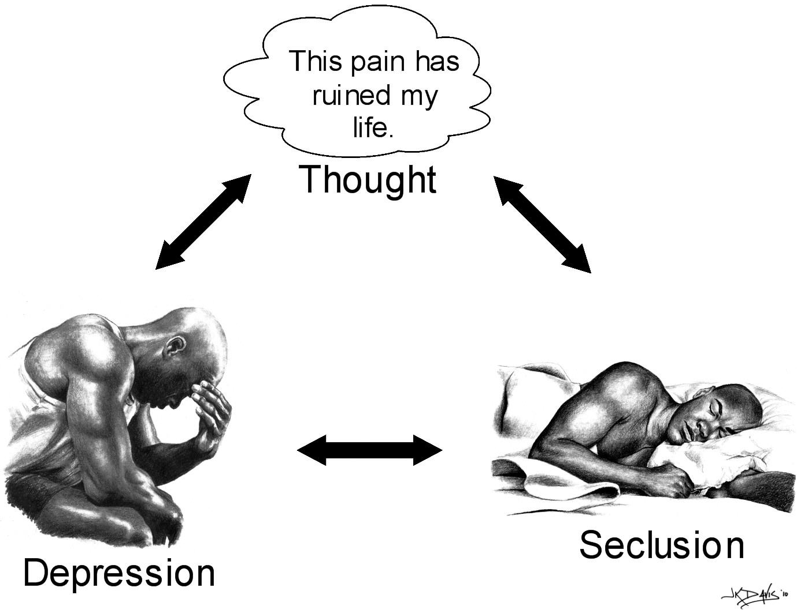
- Negative emotions and behavior cause more pain, body aches, and muscle tension.

- Negative automatic thoughts are not a good way to cope with pain or stress.

- Most negative automatic thoughts are partly true and partly distorted.

- The ATW 2 Worksheet helps you learn to
- Judge your automatic thoughts
- Find negative distorted automatic thoughts
- Stop believing your negative distorted automatic thoughts
- Cope better with your pain and stress

Session 3 Worksheet

Automatic Thoughts Worksheet ATW 2 – Example

Stressful situation. | Changes in emotions, body, or behavior. | Automatic Thoughts or Pictures in your Mind  How much do you  believe it?  0% 25% 50% 75% 100% | Evidence*  Write some facts that are true about your  Automatic Thoughts. | Evidence*  Write some facts that are not true about your  Automatic Thoughts. | How much do believe your  Automatic Thoughts Now?  0% 25% 50% 75% 100%
Notice from phone company. | Mad & nervous  All tensed up  Slamming things  Crying & yelling  Going to bed | I cannot come up with the money. - 100%  There is nothing I can do. I might as well give up. - 100% | I do not have enough money to pay all my bills each month.  I cannot borrow any more money from my mother. | My cousin is supposed to help with the phone bill – I can ask him.  I could ask my sister to help pay this bill.  I could call the phone company and see if there are other things I can do. | I cannot come up with the money. - 40%  There is nothing I can do. I might as well give up. - 30%
*What is true about my Automatic Thoughts? What is not true or distorted about my Automatic Thoughts? Most of the time Automatic Thoughts are partly true and partly distorted.
Often Automatic Thoughts are distorted in a negative way.

Session 3 Worksheet

Automatic Thoughts Worksheet ATW 2

Stressful situation. | Changes in emotions, body, or behavior. | Automatic Thoughts or Pictures in your Mind  How much do you  believe it?  0% 25% 50% 75% 100% | Evidence*  Write some facts that are true about your  Automatic Thoughts. | Evidence*  Write some facts that are not true about your  Automatic Thoughts. | How much do you believe your  Automatic Thoughts Now?  0% 25% 50% 75% 100%
*What is true about my Automatic Thoughts? What is not true or distorted about my Automatic Thoughts? Most of the time Automatic Thoughts are partly true and partly distorted.
Often Automatic Thoughts are distorted in a negative way.
Session 4

Challenge Automatic Thoughts
Create Alternative Thoughts

Session 4 Goals

- Challenge Negative Distorted Automatic Thoughts.
- Create Alternative Thoughts that are More True, Real, and Positive.

Review from Last Session
- Some thoughts about our pain or stress are completely true.
- Most thoughts about our pain or stress are partly true.
- Often thoughts about our pain or stress are a little bit distorted or twisted to make the pain or stress seem worse than it is.
- Negative Distorted Automatic Thoughts have the most harmful effect on our emotions, behavior, and bodies.
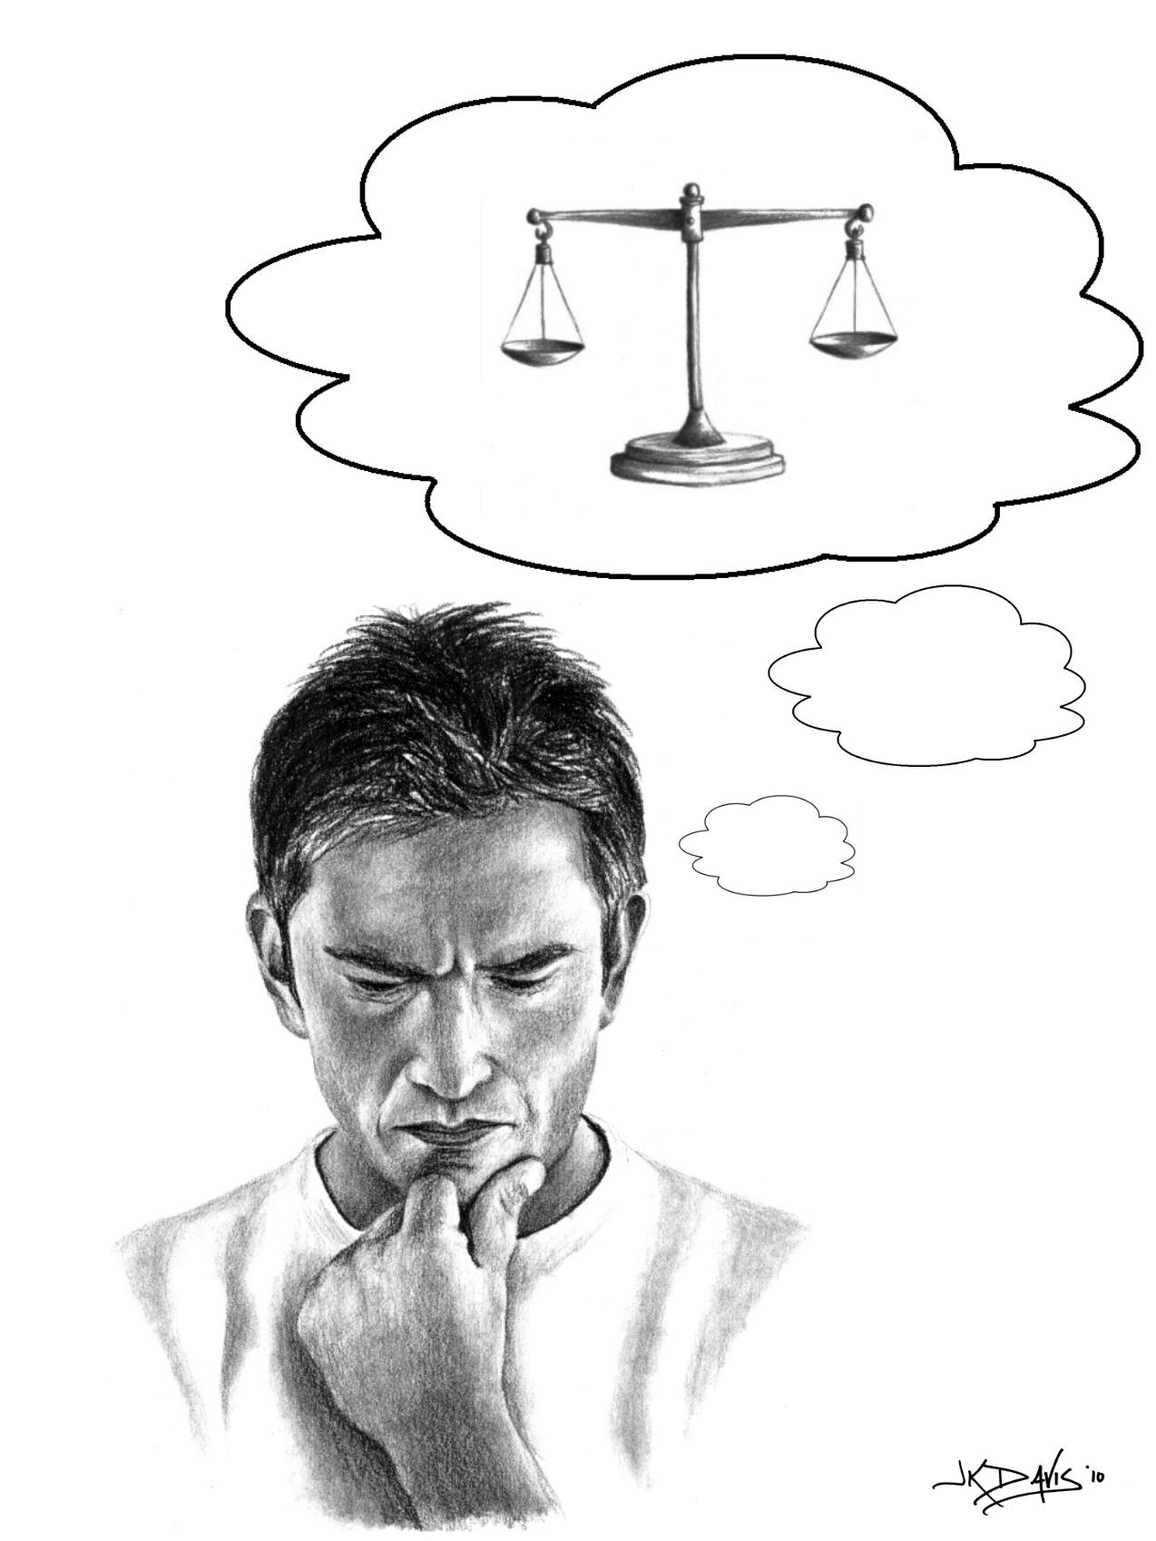

Learning Activity from Last Session
- Look at your Automatic Thoughts Worksheet ATW 2.
- Tell the group about one automatic thought from your worksheet.
- Tell about any changes in your emotions, behavior, or body when you had this automatic thought.
- How much did you believe your automatic thought or picture in your mind? 0% 25% 50% 75% 100%
- Tell facts that are true about your Automatic Thought.
- Tell facts that are not true about your Automatic Thought.
- How much did you believe your Automatic Thought after looking at the facts? Did your rating change?

Learn to Challenge Negative Distorted Automatic Thoughts
- Name the part of your Automatic Thought that is negative or distorted.
- Look at your Negative Distorted Thoughts handout from last week.
- Are you doing All or Nothing thinking?
- When people are in pain or stressed out, they think all good
or all bad thoughts.
- People forget that they can think a thought that is between
all good and all bad.
[Insert Illustration 4 here – to be determined]
- When you name the negative or distorted part of your Automatic Thoughts, you can create Alternative Thoughts.
- Alternative Thoughts are more real, useful, and positive.
- When you have more real, useful, and positive thoughts, your coping improves. When your coping improves, you feel less pain and stress.

Learning Activity Automatic Thoughts Worksheet 3 ATW 3

- We will do this together in group.

- The Automatic Thoughts Worksheet ATW 3 will help you learn to create Alternative Thoughts that are more real, useful, and positive.

Take Home Daily Learning Activity
Automatic Thoughts Worksheet 3 ATW 3
- Each day use the worksheet like we did in the group.
    - Write one important Automatic Thought each day.
    - Rate how much you believe your automatic thought 0% to 100%.
    - Create an Alternative Thought. Use the questions at the bottom of the Worksheet to help you.
- Write facts that are true about your Automatic Thought.
- Write facts that are not true about your Automatic Thought.
- Ask yourself Is there another way to look at this?
- Ask yourself If a friend had the same thought or in the same situation, what would I tell my friend?
- In the last column rate how much you believe your Automatic Thought now. 0% 25% 50% 75% 100%
- In the last column rate how much you believe your Alternative Thought. 0% 25% 50% 75% 100%
- When you say your Alternative Thought to yourself, what changes do you have in your emotions, behavior, or body? Write your changes in the last column.
- Hint – The idea of making an alternative thought is to make it just a little bit more positive and realistic
- Keep in mind that you are learning new skills. Learning new skills takes time and practice.
Bring your Take-Home Daily Learning Activity to the next session. Be ready to talk about what you learn.

Summary

- Most distorted thoughts are partly true.

  - It is the negative part that makes us feel sad or frustrated.
  - It is the negative part that makes our pain worse.

- When you name the true and not true facts or Evidence about your Automatic Thoughts, you understand them better.

- When you name the distorted part of your Automatic Thought, you can create a more realistic or positive Alternative Thought.

- When you think more realistic or positive thoughts, you feel and act better, and your body hurts less.

Session 4 Worksheet
Automatic Thoughts Worksheet ATW 3 – Example

Stressful  situation. | Changes in  emotions,  body, or  behavior. | Automatic Thoughts or  Pictures in your Mind  How much do you believe it?  0% 25% 50% 75% 100% | Alternative Thought  *Use questions below to look at  the Evidence and create an  Alternative Thought. | 1. How much do you now believe your Automatic Thought? 0% -- 100%  2. How much do you believe your Alternative Thought? 0% -- 100%  3. Write about changes in your emotions, body, or actions when you think your Alternative Thought.
Notice from phone company. | Mad & Nervous.  All tensed up.  Slamming things in the kitchen.  Crying and Yelling.  Going to Bed. | I cannot come up with the money. – 100%  There is nothing I can do. I might as well give up. – 100% | There are some things I can do. I will ask some family members for money. I will ask the phone company for bill paying ideas. | Automatic Thoughts  I cannot come up with the money. – 40% I really don’t know yet!  There is nothing I can do. I might as well give up. – 0%  Alternative Thought  There are some things I can do. I will ask some family members for money. I will ask the phone company for bill paying ideas. – 90%  Changes in Emotions, Body, Actions  I am in a little better mood.  I still hurt, but not as bad because my focus is on finding the money to pay the bill.  I am out of bed and making phone calls.
*Evidence - What is the evidence to support your Automatic Thoughts? Write the facts that are true about your Automatic Thoughts.
What is the evidence that does not support your Automatic Thoughts? Write the facts that are not true about your Automatic Thoughts.
Ask yourself Is there another way to look at this? Ask yourself If a friend had this same thought or in the same situation, what would I tell my friend?
Session 4 Worksheet
Automatic Thoughts Worksheet ATW 3

Stressful  situation. | Changes in  emotions,  body, or  behavior. | Automatic Thoughts or  Pictures in your Mind  How much do you believe it?  0% 25% 50% 75% 100% | Alternative Thought  *Use questions below to look at  the Evidence and create an  Alternative Thought. | 1. How much do you now believe your Automatic Thought? 0% -- 100%  2. How much do you believe your Alternative Thought? 0% -- 100%  3. Write about changes in your emotions, body, or behavior when you think your Alternative Thought.
*Evidence- What is the evidence to support your Automatic Thoughts? Write the facts that are true about your Automatic Thoughts.
What is the evidence that does not support your Automatic Thoughts? Write the facts that are not true about your Automatic Thoughts.
Ask yourself Is there another way to look at this? Ask yourself If a friend had this same thought or in the same situation, what would I tell my friend?
Session 5
Should Beliefs

Session 5 Goals

- Understand and Name Your Should Beliefs
- Should Beliefs are Rules about
- How you should be
- How other people should be
- How the world should be
- Challenge Negative and Distorted Should Beliefs.
- Create Alternative or New Beliefs that are more Real, Positive and Useful.

Review from Last Session
- Most distorted thoughts are partly true.
  - It is the negative part that makes us feel sad or frustrated.
  - It is the negative part that makes our pain worse.
- When you name the true and not true facts or Evidence about your Automatic Thoughts, you understand them better.
- When you name the distorted part of your Automatic Thought, you can create a more real, positive, and useful Alternative Thought.
- When you think thoughts that are more real, positive, and useful
  - You feel and act better.
  - Your body hurts less.

Learning Activity from Last Session
- Look at your Automatic Thoughts Worksheet 3 ATW 3.
- Tell one important Automatic Thought you had this week.
- Tell how much you believed your automatic thought 0% to 100%.
- What Alternative Thought did you come up with? Did you use the questions at the bottom of ATW 3 Worksheet to help you write the Alternative Thought?
- Did you write facts that are true about your Automatic Thought?
- Did you write facts that are not true about your Automatic Thought?
- Did you ask yourself Is there another way to look at this?
- Did you ask yourself If a friend had the same thought or in the same situation, what would I tell my friend?
- Look at your last column. How much do you now believe your Automatic Thought? How much do you believe your Alternative Thought?
- When you said your Alternative Thought to yourself, what changes did you have in your emotions, body, pain, or behavior?

Understand Your Should Beliefs

Should Beliefs

Rules about the way you think you should be

Rules about the way you think other people should be

Rules about the way you think the world should be

People have different Should Beliefs about themselves, other people, and the world.

Can you think of some examples?

Should Beliefs affect your Automatic Thoughts.

You can learn about your Should Beliefs by paying attention to your Automatic Thoughts.

Learning Activity Naming Should Beliefs Worksheet
- We will do this together in group.

Learning Activity Changing Should Beliefs Worksheet
- We will do this together in group.

Take Home Daily Learning Activity

Changing Should Beliefs Worksheet

- Each day use the worksheet like we did in the group.

- Write an important Automatic Thought in the first column.

- Hint – Ask Yourself – If my Automatic thought is true, what does it mean to me? Your answer may be your Should Belief.

- Write a Should Belief related to your Automatic Thought in the next column.

- Keep in mind that Should Beliefs are Rules about

- How you should be.
- How other people should be.
- How the world should be.

- Next write some Evidence about your Should Belief using the questions at the bottom of the worksheet.

- Write some facts that are true about your Should Belief.
- Write some facts that are not true about your Should Belief.
- Write some Drawbacks – some problems that might happen if you
hold onto this Should Belief.
- Write some Benefits – some good things that might happen if you hold onto this Should Belief.
- Keep in mind that these Benefits may seem good at the time, but in the long run they may not be so good.
- Think about the Changing Should Beliefs Worksheet-Example from today.
- If I believe I should be able to do things right all the time, then I might believe I am perfect. People would really like me and look up to me if I did things right all the time.
- Is this really a benefit? Or am I setting myself up to fail? (Hint: What will I think of myself if I don’t do things perfect all the time?)

- Write your Alternative or New Belief to replace your Should Belief.

- Use the Evidence to help you.
- Hint – Do not make your Alternative or New Belief so positive that it is not realistic. Make your new belief a little bit more positive.

Bring your Learning Activity to the next session. Be ready to talk about what you learn.

Summary

- Important Automatic Thoughts
  - Come to your mind over and over again
  - They may be related to your Should Beliefs

- Should Beliefs are Rules about
- How you should be
- How other people should be
- How the world should be

- Your Should Beliefs are also ideas.
  - Ideas are not set in stone.
  - You can challenge and change ideas.
- Should Beliefs can get distorted during stressful times.
- Negative Distorted Should Beliefs have a negative effect on your
thoughts, emotions, body, behavior, or pain.
- We must name our Negative Distorted Should Beliefs to change
them.
- You can challenge negative Should Beliefs by looking at the
drawbacks and benefits of holding onto them.
- Keep in mind
  - Drawbacks are problems that might happen if you hold onto your Should Belief.
  - Benefits are good things that might happen if you hold onto your Should Belief.

All these negative thoughts and beliefs are extra
baggage to carry around!



- Create an Alternative or New Belief that is more real, positive, and useful.

Session 5 Worksheet

Naming Should Beliefs Worksheet - Example

Situation
There was no supper made for the family tonight.

Automatic Thought
My family thinks I do not do enough for them.

Hint - If this automatic thought is true, what does it mean to you?
Your answer may be your should belief. ↓

Should Belief

I should cook supper every night for my family.

Session 5

Naming Should Beliefs Worksheet

Situation

Automatic Thought

Should Belief

Session 5
Changing Should Beliefs Worksheet—Example

Automatic Thought  How much do you believe it?  0%-100% | Should Belief  How much do you believe it?  0%-100% | *Evidence →  Facts that are True about Should Belief  Facts that are Not True about Should Belief  Advantages / Disadvantages | *Alternative Belief  1. Look at your Evidence. Create an Alternative Belief. How much do you believe your Alternative Belief?  0%-100%  2. How much do you now believe your original Should Belief? 0-100%
I don’t do anything right! 90% | I should be able to do things right all the time. 90% | True:  That’s right. People expect me to do things for them, and I should be able to do it right.  Not True:  I don’t know anyone who does things right all the time. No one’s perfect!  How does my Should Belief hurt me → Disadvantages?  If I think I should be able to do things right all the time, then I’m always going to be disappointed.  How does my Should Belief help me → Advantages?  It doesn’t help me at all. It makes me feel bad about myself. | Alternative Belief  I will try to do things right, but it is normal to make mistakes sometimes. 80%  Original Should Belief  I should be able to do things right all the time. 20%
*Evidence: Write some facts that are true about your Should Belief. Write some facts that are not true about your Should Belief.
Write some Disadvantages → How does my Should Belief hurt me? Write some Advantages → How does my Should Belief help me?
Session 5 Worksheet
Changing Should Beliefs Worksheet

Automatic Thought  How much do you believe it?  0%-100% | Should Belief  How much do you believe it?  0%-100% | *Evidence  Facts that are True about Should Belief  Facts that are Not True about Should Belief  Drawbacks / Benefits | *Alternative Belief  1. Look at your Evidence. Create an Alternative Belief. How much do you believe your Alternative Belief?  0%-100%  2. How much do you now believe your original Should Belief? 0-100%
True Facts

Not True Facts

Drawbacks – Problems that might happen if I hold onto this Should Belief

Benefits – Good things that might happen if I hold onto this Should Belief

*Evidence- Write some facts that are true about your Should Belief. Write some facts that are not true about your Should Belief.
Write some Drawbacks – Problems that might happen if I hold onto this Should Belief. Write some Benefits – Good things that might happen if I hold onto this Should Belief. (Hint: Things that may seem like benefits at the time may not really be benefits.)
Session 6

Core Beliefs

Session 6 Goals
- Understand and Name Your Core Beliefs.
- Core Beliefs are

Beliefs about yourself and the world

Beliefs you had as a young child

Beliefs you still have today
- Beliefs you hold very deep within you
- Challenge Negative and Distorted Core Beliefs.
- Create Alternative or New Core Beliefs that are
      - More real
      - More positive
      - More useful

Review from Last Session

Should Beliefs

Rules about how you should be.

Rules about how other people should be.

Rules about how the world should be.

When you have an Automatic Thought, ask yourself

If this Automatic Thought is true, what does it mean to me?

Your answer may be your Should Belief.

Like our Automatic Thoughts, our Should Beliefs may have parts that are not true.

- Sometimes when we hold onto beliefs that are not completely true, we may run into drawbacks or problems.

- Other times when we hold onto beliefs that are not completely true, we have benefits or good things might happen.

- Your Should Beliefs are ideas.
- Ideas are not set in stone.
- You can challenge ideas. You can change ideas.

Learning Activity from Last Session
- Look at your Changing Should Beliefs Worksheet.
- Tell about one of your Should Beliefs?
- What did you write for Evidence about your Should Belief?
- What facts are true about your Should Belief?
- What facts are not true about your Should Belief?
- What are some Drawbacks - Name some problems that might happen if you hold onto this Should Belief?
- What are some Benefits - Name some good things that might happen if you hold onto this Should Belief?
- Did you come up with an Alternative or New Belief to replace your original Should Belief?
- Keep in Mind
- Do not make your Alternative Belief so positive that it is not realistic.
- Make your Alternative or New Belief a little bit more positive than the original Should Belief.
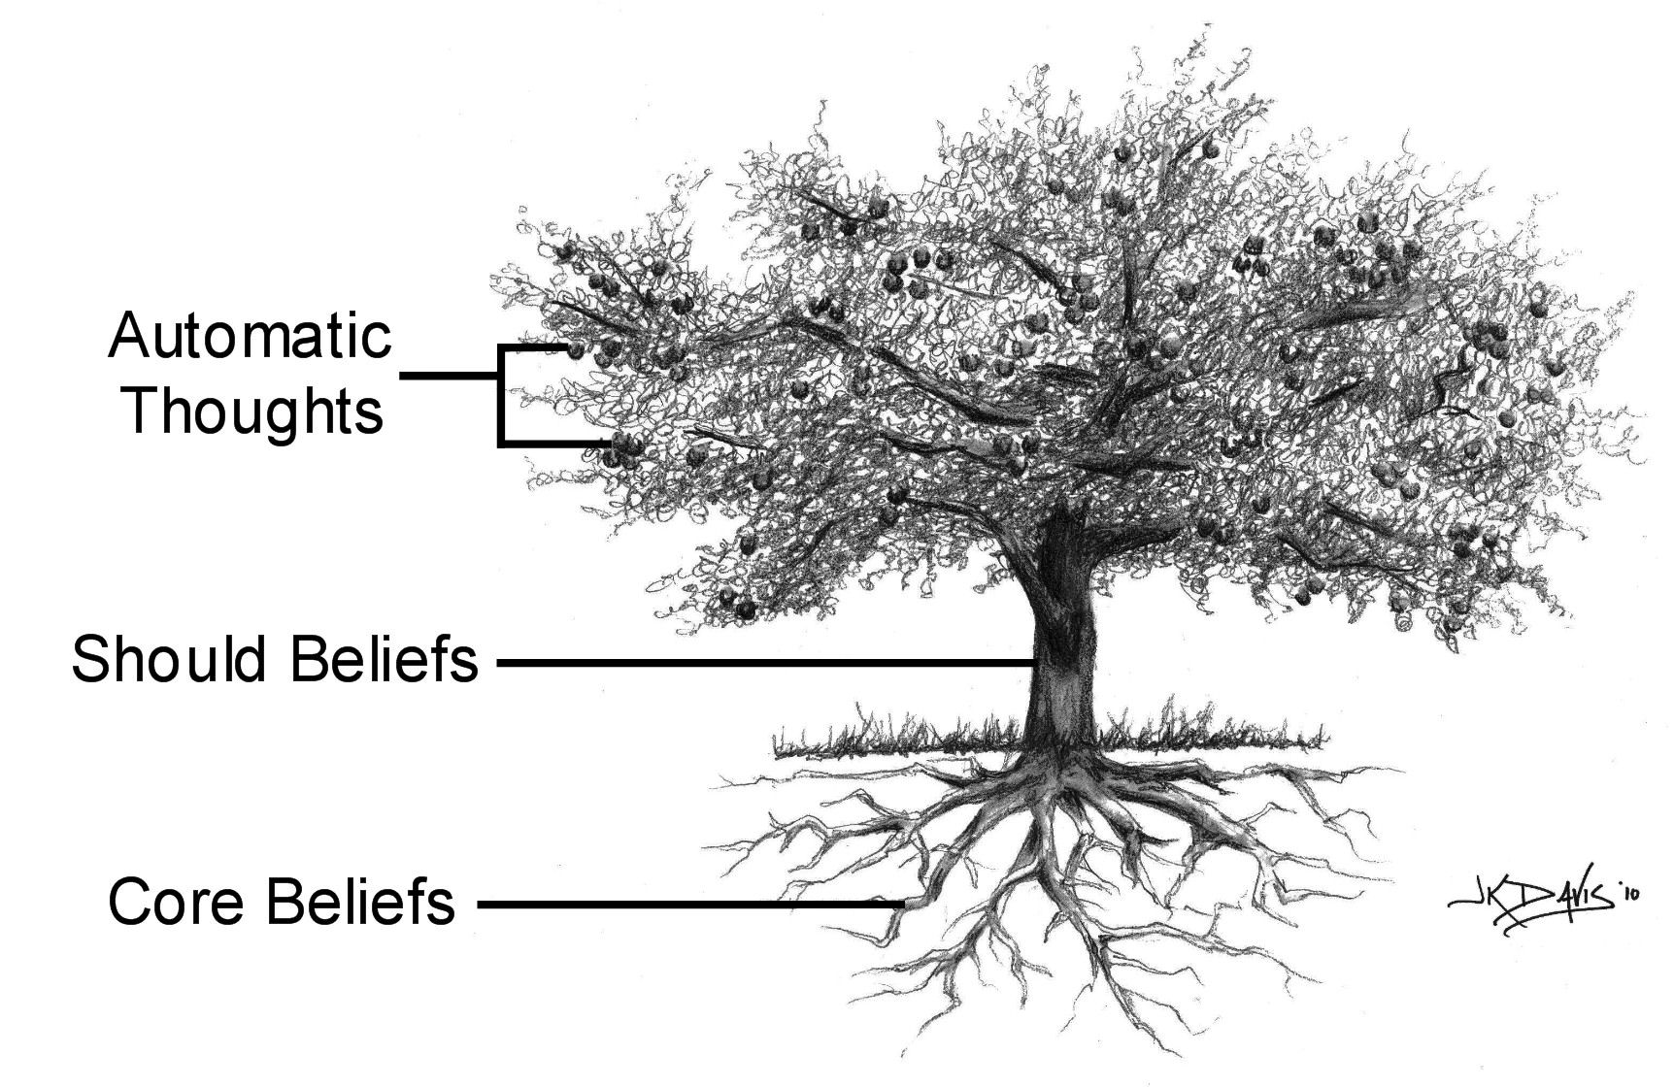

Understand Your Core Beliefs
- Core Beliefs are

Beliefs you have had about yourself and the world since you were a young child
- Beliefs you hold very deep within you
- Part of your basic core as a human being

Beliefs that affect your Automatic Thoughts

Beliefs that affect your Should Beliefs

Beliefs that can be Positive or Negative

- Your negative Core Beliefs come out during stressful times.

- Negative Distorted Core Beliefs have a negative effect on your thoughts, emotions, body, behavior, or pain.

- Like your Should Beliefs, Core Beliefs are also ideas.
- Ideas are not set in stone.
- You can challenge and change ideas.

- We must name our Negative Distorted Core Beliefs to change them.

- You can challenge negative Core Beliefs by looking at the
- Drawbacks - problems that might happen if you hold onto
the negative Core Belief.
- Benefits – good things that might happen if you hold onto the negative Core Belief.

Learning Activity Naming Your Core Beliefs Worksheet
- We will do this together in group.

- Learning Activity Changing Core Beliefs Worksheet
- We will do this together in group.

Take-Home Daily Learning Activity
Changing Core Beliefs Worksheet
- Each day use the worksheet like we did in the group.
- Write an important Automatic Thought in the first column.
- Hint – Ask Yourself – If my Automatic thought is true, what does it mean to me? Your answer may be your Should Belief.

- Write a Should Belief related to your Automatic Thought in the next column.
- Write a Core Belief related to your Automatic Thought or your Should Belief in the next column.
- Hint – Ask Yourself – If my Automatic Thought is true, what does it mean about me? Your answer may be your Core Belief.

- Keep in mind that Core Beliefs are

Beliefs you have had about yourself and the world since you were a young child
- Beliefs you hold very deep within you
- Beliefs that are part of your basic core as a human being

Beliefs that affect your Automatic Thoughts

Beliefs that affect your Should Beliefs

Beliefs that can be Positive or Negative

- Next write some Evidence about your Core Belief using the
questions at the bottom of the worksheet.
- Write some facts that are true about your Core Belief.
- Write some facts that are not true about your Core Belief.
- Write some Drawbacks – some problems that might happen if you hold onto your Core Belief.
- Write some Benefits – some good things that might happen if you hold onto your Core Belief.
- Keep in mind that these Benefits may seem good at the time, but in the long run they may not be so good.

- Think about the Changing Core Beliefs Worksheet-Example from today.

- If I believe that I am defective, then I have got an excuse, and I will not need to be bothered with trying to exercise and eat right. I will plop my defective self on the couch!

- Is this really a benefit? Or am I setting myself up to fail? (Hint: When I stop exercising and eating right and just sit around all day, my pain often gets worse. I also get in a bad mood.)

- Write an Alternative or New Core Belief to replace your
original Core Belief in the last column.
- Use the Evidence to help you.
- Do not make your Alternative Core Belief so positive that it is not real.
- Make your Alternative or New Core Belief a little bit more positive than the original one.

- Test out your Alternative or New Core Belief by acting as if it is true.
- See what happens.
- You can try acting as if your new core belief is true even if you do not believe it.
- Often when we act as if - our behavior changes.
- Then our new behavior - changes our belief.

Bring your Take-Home Daily Learning Activity to the next
session. Be ready to talk about what you learn.
Summary
- Your Core Beliefs are ideas.
  - Ideas are not set in stone.
  - You can challenge and change ideas.
- Core Beliefs can get distorted and negative at stressful times.
- Distorted Core Beliefs have a negative impact on your thoughts, emotions, body, and behavior.
- Naming negative Core Beliefs is the first step to change them.
- You can challenge a Negative Core Belief by looking at the
  - Drawbacks or problems you might have if you hold onto it.
  - Benefits or good things you might get from holding onto it.
- Create a more realistic or positive Alternative or New Core Belief.
- Try out your Alternative Core Belief by acting as if. See what happens.
Session 6 Worksheet

Naming Core Beliefs Worksheet - Example

Situation
There was no supper made for the family tonight.

Automatic Thought
My family thinks I do not do enough for them.

Hint - If this automatic thought is true, what does it mean about you?
This may be your core belief. ↓

Should Belief

I should cook supper every night for my family.

Core Belief

I am useless!

Session 6

Naming Core Beliefs Worksheet

Situation

Automatic Thought

Should Belief

Core Belief

Session 6 Worksheet

Changing Core Beliefs Worksheet—Example

Automatic Thought  How much do you believe it?  0% - 100% | Should Belief  How much do you believe it?  0% - 100% | Core Belief  How much do you believe it?  0% - 100% | *Evidence for or Against Core Belief  Facts that are True about Core Belief  Facts that are Not True about Core Belief  Drawbacks / Benefits | *Alternative Belief  1. Look at your Evidence. Create an Alternative Core Belief. How much do you believe your Alternative Core Belief? 0%-100%  2. How much do you now believe your original Core Belief? 0-100%
I do not deserve this horrible pain. 100% | There should be a cure for pain like this! 100% | I am defective. 100% | True Facts  I have horrible pain that other people do not have.  Not True Facts  I have a lot of pain, but I also have a lot of positive qualities.  Drawbacks – Problems that might happen if I hold onto this Core Belief  If I tell myself that I am defective, then I will feel hopeless, and I will not try to exercise and do things to help myself.  Benefits – Good things that might happen if I hold onto this Core Belief  If I tell myself that I am defective, then I have got an excuse, and I will not need to be bothered with trying to exercise and eat right. I will plop my defective self on the couch!  Is this really a benefit? Or am I setting myself up to fail? When I stop exercising and eating right and just sit around all day, my pain often gets worse. I also get in a bad mood. | Alternative Core Belief  I am a normal person with some strengths and some weaknesses. 80%  Original Core Belief  I am defective. 20%
*Evidence - Write some facts that are true about your Core Belief. Write some facts that are not true about your Core Belief.
Write some Drawbacks – Problems that might happen if I hold onto this Core Belief. Write some Benefits – Good things that might happen if I hold onto this Core Belief. (Hint: Things that seem like benefits at the time may not really be benefits)

Session 6 Worksheet

Changing Core Beliefs Worksheet

Automatic Thought  How much do you believe it?  0% - 100% | Should Belief  How much do you believe it?  0% - 100% | Core Belief  How much do you believe it?  0% - 100% | *Evidence for or Against Core Belief  Facts that are True about Core Belief  Facts that are Not True about Core Belief  Drawbacks / Benefits | *Alternative Belief  1. Look at your Evidence. Create an Alternative Core Belief. How much do you believe your Alternative Core Belief? 0%-100%  2. How much do you now believe your original Core Belief? 0-100%
True Facts

Not True Facts

Drawbacks – Problems that might happen if I hold onto this Core Belief

Benefits – Good things that might happen if I hold onto this Core Belief
*Evidence - Write some facts that are true about your Core Belief. Write some facts that are not true about your Core Belief.
Write some Drawbacks – Problems that might happen if I hold onto this Core Belief. Write some Benefits – Good things that might happen if I hold onto this Core Belief (Hint: things that seem like benefits at the time may not really be benefits).
Session 7

Coping Statements
Relaxation
Session 7 Goals
- Create and Use Positive Coping Statements.

- Learn a Simple Relaxation Practice.

- Use a Coping Statement in your Relaxation Practice.

Review from Last Session
- Your Core Beliefs are ideas you have had about yourself and your world for many years.
  - It is important to remember that ideas are not set in stone.
  - Your Core Beliefs can be challenged and changed.
- Your Core Beliefs tend to become more negative or distorted during stressful times.
  - These distorted core beliefs
    - make our thoughts and feelings negative
    - create more body aches and pains
    - affect our behavior-all we want to do is sit and feel bad
- Naming negative distorted core beliefs is the first step to changing them.
- You can challenge negative core beliefs by looking at the drawbacks and benefits of holding onto them.
- Create an Alternative or New Core Belief that is more realistic or positive.
- We can try acting as if the new core belief is true even if we do not believe it.
- Often when we act as if the new core belief is true
  - Our behavior improves
  - Our belief changes to be more positive

Learning Activity from Last Session
- Look at your Changing Core Beliefs Worksheet.
- Tell how your Automatic Thoughts relate to your Should Beliefs or Core Beliefs.

- It is easy to name the drawbacks of a negative core belief

Drawbacks are problems that might happen by holding onto a negative Core Belief.

- It is harder to name the benefits of a negative core belief

Benefits are good things that might happen by holding onto a negative core belief.
Keep in Mind - These benefits may not really be good for us.

- What did you learn about the drawbacks and benefits of your negative core beliefs?
- What happened when you acted as if your new core belief was true?

- Did you feel differently about yourself?
- Did other people treat you differently?

Sense of Control
- Where does your sense of control come from?
- Is your sense of control external – outside of you?
- Or is your sense of control internal – inside you?

- When your sense of control is external
- You feel more in control when other people tell you how to manage your pain.
- You feel lost when other people do not tell you how to manage your pain.

- When your sense of control is internal
- Your sense of strength and well being comes from within you.
- You know you can manage your pain no matter what.

Self-efficacy
- People with a sense of self-efficacy have a strong belief in themselves.
  - They believe they can manage their pain.
  - They believe they can manage every part of their lives.

Create and Use Positive Coping Statements
- Coping statements are like Cheerleaders!
- Coping statements lift your mood.
- Reading coping statements makes you feel more hopeful.
- Coping Statements
  - Are positive words to help us cope with our pain
  - Help us feel more in control of our lives
  - Help us believe in ourselves
  - Help us live better with our pain
- Write positive words to help you cope with your pain on small index cards. These are called Coping Cards.
- You put Coping Cards in places where you will see them often.
- You will read your Coping Cards when you see them.
- Reading your Coping Cards helps you know you can cope with your pain.
Learning Activity Creating Coping Cards
- We will do this together in group.
- Look at your Coping Statements Handout. Read the examples of positive Coping Statements to help write your own.

Learning Activity Relaxation Practice
- Relaxation Practice
- We will do this together in group.
- Choose one coping statement to help you focus.
- During this guided relaxation practice
- Breathe deeply
- Relax your muscles
- Think about your coping statement
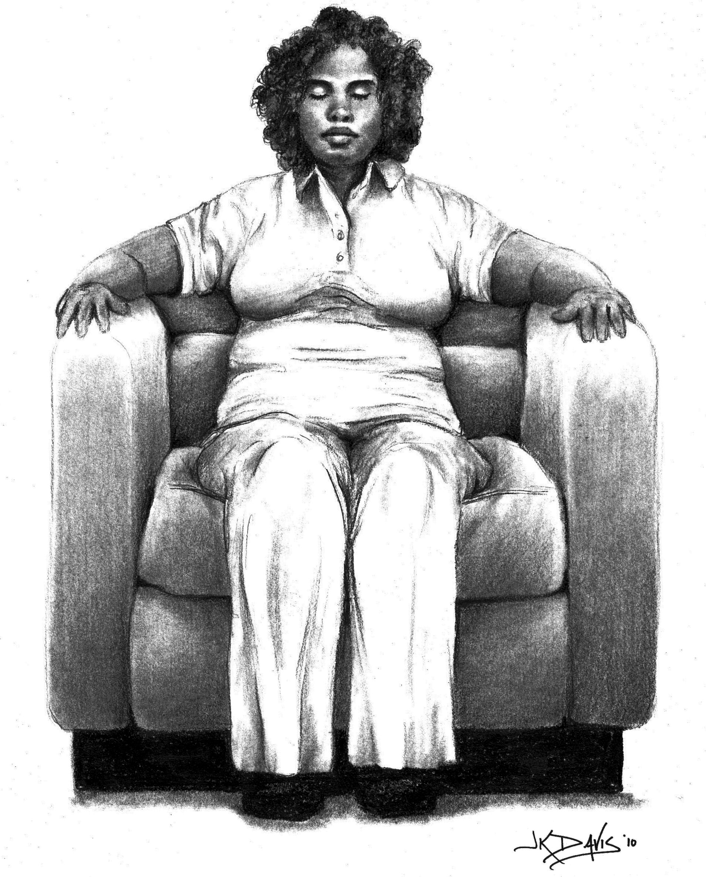

- Keep in mind that Practicing Relaxation
- Helps to increase your internal sense of control
- Your sense of strength and well being comes from within you.
- You know you can manage your pain no matter what.
- Helps to increase your sense of self-efficacy
- You have a strong belief in yourself. You know you can manage your pain and every part of your life.

Take-Home Daily Learning Activity

- Each day practice relaxation using your coping statements like we did in the group.
- Write more coping statements on small cards.
- Put only one coping statement on each card.
- Put your coping cards in places you will see often.
- Read coping cards often.
- Practice relaxation by
  - Listening to your relaxation CD
  - Breathing deeply
  - Relaxing your muscles
  - Thinking in a calm way
  - Paying attention to a peaceful word or a saying that makes you feel happy – a coping statement

Be ready to talk about your Take-Home Daily Learning Activity at our next session
- Practice Relaxation using your Coping Statements
- Make more coping cards. Read coping cards often.
Be ready to share what you learn.

Summary
- A coping statement is a positive belief about you.
- Coping statements give you an internal sense of control over you and your pain.
- Coping statements increase your self-efficacy.
- Use Coping Cards to write positive beliefs about yourself.
    - Put coping cards in a place you will see often.
    - Read your coping cards when you see them.
- Relaxation exercises focus on
  - Breathing
  - Relaxing your muscles
  - Thinking in a calm way
  - Paying attention to a peaceful word or a saying that makes you feel happy – a coping statement

Session 7 Handout

Coping Statements Handout

- I am brave and strong even with my pain.
- I am not my pain. I am a blessed human being who has pain.
- I will not let my pain stand in the way of what I need to do.
- I can still do things. I just need to do them differently.
- This too shall pass.
- Relaxation helps ease my mind and my pain.
- I may not be able to eliminate my pain, but there are some things I can do to make it better.
- Self-care is not self-ish.

Session 8
Express Yourself

Session 8 Goal
- Learn and practice ways to express yourself.

Review of Last Session
- Coping statements are our Cheerleaders!
- When we read coping statements we feel hopeful.
- Coping statements lift our mood.
- Coping statements help us feel more in control of our lives.
- Coping statements help us believe in ourselves.
- Coping statements help us live with our pain.
- Coping statements are positive words to help cope with our pain.
- Relaxation exercises focus on
  - Breathing
  - Relaxing your muscles
  - Thinking in a calm way
  - Paying attention to a peaceful word or a saying that makes you feel happy - a coping statement
Learning Activity from Last Session
- We write our coping statements on Coping Cards.
- What coping statements did you put on your coping cards?
- Where did you put your coping cards?
- What did you learn using the coping cards learning activity?
- Did you use coping statements in your relaxation exercise?
- What was your experience with the relaxation practice?

Understand how to Express Yourself
- Writing or talking about pain or other life stressors may bring up
feelings and thoughts we may not know we have.
- Or you may be aware of some of your negative thoughts
and feelings, but are too afraid to let them out, for fear of getting
carried away.
- Writing and talking about our deepest feelings and thoughts helps
us realize something. We have more control over negative feelings
than we might think.
- Writing and talking about our deepest thoughts and feelings helps
us understand them in a different way.
- There are 2 ways you can Express Yourself.
- You can write about your feelings and thoughts.
- You can talk into a tape recorder about your feelings and thoughts.
- You can write or talk about any feelings or thoughts.
- Your feelings and thoughts about your pain
- Your feelings and thoughts about any part of your life
Learning Activity Express Yourself Learning Activity Handout
- We will do this together in group.


Take-Home Daily Learning Activity
- Do the Express Yourself activity for at least 3 days in a row during this week.
- Each time you do the Express Yourself activity write or talk for at least 10 minutes.
- Use your Express Yourself Learning Activity Handout.

Summary
- The Express Yourself activity helps you learn more about your feelings and your thoughts.
- The Express Yourself activity is a way to get strong feelings out without making other people feel uneasy.
- The Express Yourself activity is just for you. It is not a tool for communicating with other people.
- You can keep what you write or you can throw it away.
- You can save what you say on the tape or you can erase the tape.
- If your writing or talking upsets you, change the topic and continue writing or talking. You are in charge!

Session 8 Handout

Express Yourself Learning Activity
- Each time you do the Express Yourself activity, write or talk for 10 minutes.
- Do the Express Yourself activity 3 days in a row during this week.
- You can write or talk more if you want to. Be sure to Express Yourself at least 3 days in a row.
- Keep in mind that there are 2 ways you can do the Express Yourself activity.
- You can write about your feelings and thoughts.
- You can talk into a tape recorder about your feelings and thoughts.
- When you write or talk do it just for you! You do not have to share this with anyone. You can write or talk about anything you want.
- Your pain
- Changes you have made in your life because of your pain
- Your childhood
- Your loved ones
- Your ideas about who you are now and who you want to be in the future
- You can choose to write about the same thing every day, or you can write about different things each day.
- It is normal to experience many different feelings during this activity.
  - You might feel sad. You might feel angry.
  - It is OK to write or talk about your sad or angry feelings.
  - If you become upset about your words, you can change the subject. The important thing is to keep writing or talking.
- Spelling and grammar are not important.
- There is no wrong way to do this activity.
- The Express Yourself activity is just for you. You are in charge!
Session 9
Assertive Communication

Session 9 Goals
- Learn about assertive communication
- Plan an assertive communication

Review from Last Session
- There are 2 ways you can do the Express Yourself activity.
  - You can write about your feelings and thoughts.
  - You can talk into a tape recorder about your feelings and
thoughts.
- Writing or talking about your feelings and thoughts helps you
cope better with medical problems like chronic pain.
- Writing or talking about your deepest thoughts and feelings
helps you understand yourself better.
- Writing or talking about your negative feelings and thoughts
helps to lay them aside for a while.
- This puts you in charge of those negative feelings and
thoughts!
- Sometimes writing or talking about your negative thoughts
and feelings makes them less negative.
- Sometimes writing or talking about your negative thoughts
and feelings makes you feel more positive.
- Writing or talking into a tape recorder about negative feelings
and thoughts does not hurt other people. You write and talk
just for yourself. You do not bother other people with your
negative feelings and thoughts.

Learning Activity from Last Session
- What did you learn from doing the Express Yourself activity?
- Did you write or talk into a tape recorder 3 days in a row?
- Did your writing or talking change over time? Or Did you write about the
same thing every day?
- Did your feelings change as you kept writing or talking?
- Is the Express Yourself activity useful for you?
- How did writing or talking about your feelings and thoughts help you?
- Will you use the Express Yourself activity again?
- You can keep your writing or you can throw it away.
- You can save what you say on tape or you can erase the tape.
- You can choose what to do with your Express Yourself activity.
Learn about 3 Different ways of Communicating
- Aggressive
- We tell our opinions, feelings or wants in a way that does not show respect and hurt others feelings.
- We are aggressive when we say – I am powerful and right. You are weak and wrong. or My needs are more important than your needs.

  - Passive
  - We tell only part of our opinions, feelings or wants. We hold back some.
  - We are passive when we say – You are powerful and right.
I am weak and wrong. or Your needs are more important than my needs.

  - Assertive
  - We tell our opinions, feelings or wants in a clear way that show respect and do not hurt others feelings.
  - We are assertive when we say - We deserve to have our opinions and to tell them to one another. Both of our needs are important.

Learn about Assertive Communication

- Why learn to be assertive?
- Most of us are not always good at communicating with other people.
- Sometimes we ask for what we need or want.
- Sometimes we say No to family members and friends.
- Many people with chronic pain have special needs.
- Often people with pain do not ask for what they need.
- You have the right to express your feelings.
- You have the right to ask for what you need and want.
- You have the right to say No.
- What does Assertive Communication mean?
- Talking and behaving to help you
  - Express your feelings
  - Ask for what you want
  - Say No to something you do not want
- To be assertive means to
  - Know your own feelings, needs or wants
  - Communicate your feelings, needs or wants to others
  - Remember that other people cannot read your mind!
- Learn assertive behavior
- Look directly at people when you talk to them
- Hold an open body posture
- Stand your ground
- Stay calm
- Learn assertive words
  - Use simple and direct I statements when you do not agree with something
  - Tell your feelings
  - Make requests. Ask for what you need and want.

Learning Activity Tips for Assertive Communication Handout
- We will do this together in group.
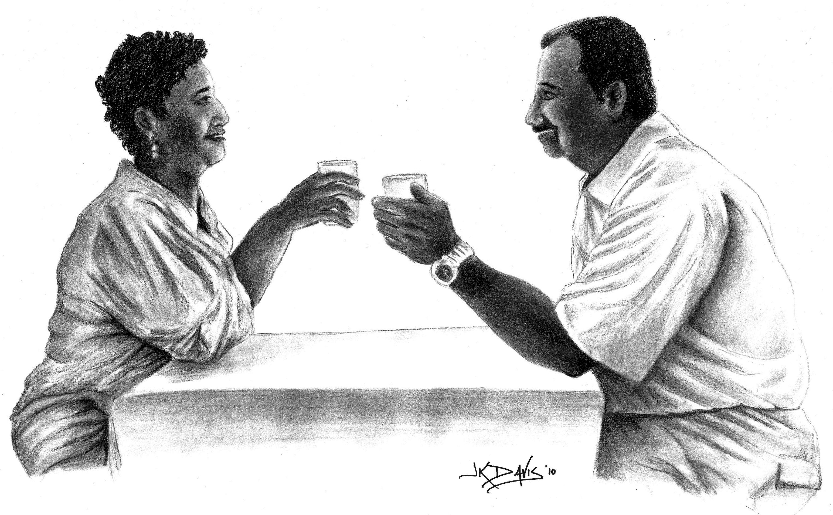
Learning Activity Plan an Assertive Communication
- We will do this together in group.
- We will use
    - The Assertive Communication Worksheet
    - The Assertive Communication Example Worksheet

Take-Home Daily Learning Activity
Assertive Communication Worksheet
- During this week make one assertive communication plan like we did
in group.
- Use the Assertive Communication Worksheet.
- Follow through with the assertiveness plan.
- Choose a problem situation that has meaning for you.
- Do not choose your most challenging problem situation.
- Start using assertive communication a little bit at a time.
- When you start with a problem that is not so bad then
- Your chances of success are better.
- Your successful assertive communication will boost your self-confidence.
- Come to the next group ready to talk about your assertive
communication learning activity.

- Next week is our last group meeting

- Think about questions you have about this group.
- Think about where you want to go from here.
- Think about what you really liked about the group.
- Think about what you did not like so well about the group.
- Think about what you might change about the group to make it better.
- Come to the next group ready to talk about your thoughts and feelings about our group.

Summary
- You have a right to express your wants and needs in a direct way.
- You do not have to apologize for asking for what you need or want.
- Assertive communication helps you
- Ask for what you need or want
- Say No to something you do not want
- Assertive communication is not mean or selfish.
- Assertive communication helps people know where you stand.
- Your loved ones may not be used to assertive communication.
- Most people respond well to assertive communication.
Session 9 Handout

Tips for Assertive Communication
Step 1-Name the Problem
Think about one difficult situation for you right now. Choose a situation that is not too hard, but one that means something to you. Think how you would answer these questions.
- What is your problem situation?

- Who is involved?

- How does this situation make you feel?

- What do you want?

- What is your normal way to deal with this problem?

- What will happen if you give an assertive answer?

Step 2-Plan Your Assertive Statement or Request
- Remind yourself you have the right to ask for what you want.
- Write your response ahead of time to increase your chance for success.
- Write a good time and place for you to meet and talk about the situation with
the person involved.
- Write the problem the way you want to say it to the other person.
- Write your assertive statement or request.
Here are some Guidelines
- Tell what the problem is in a simple and direct way.
  - Ask for one thing at a time.
  - Do not apologize for asking for what you want or need.
- Use I rather than you statements.
  - When you use I statements you show that you are responsible for your
feelings.
  - You statements often make other people feel defensive.
  - When people feel defensive they do not listen.
- Good Assertive Example I feel left out when you and the kids go
to the movies without asking me.
- Non-Assertive Example You do not care about me or my feelings.
You take the kids to the movies without even asking me.
- Do not complain about the other person.
- If you have to complain, do it about the other person’s behavior.
- Do not accuse or blame the other person.
- Do not mock or insult the other person.
- Do not say why you should get what you ask for.
- Do not say why the other person should do what you ask them to do.
- Do not demand or order the person to do what you want.
- Demands are aggressive, forceful and not friendly
- Demands cause the other person to be defensive, guarded and not trusting
- Demands cause the other person to be less willing to solve the problem
- Demands are a distorted belief that you are always right
- Demands are distorted beliefs that you should always get want you want
- Tell the other person the consequence or end result if they do
what you ask them to do.
- Tell the other person about the positive feelings you will have if they do
what you ask them to do.
- Tell the other person about the negative feelings you will have if they do not
do what you ask them to do.
- Good Assertive Example When you plan to go to the movies, I like when
you ask me if I want to go. Even if I say NO, I like for you to ask me
anyway. Then I feel more like part of the family.
- Non-Assertive Example I am a member of this family even though I have
chronic pain. I know you think I am a sick and worthless person. I say
NO a lot, but I think it is about time you show some respect by asking me if
I want to go to the movies. If you do not ask me, then I may not be here
when you get back!
- How to say No to something someone asks you to do.
- Say No in a polite, simple and direct way.
- Good Assertive Examples
  - No thank you.
  - No I am not interested.
  - No I am not able to do that.
- Non-Assertive Example
- Why do you always ask me to do things you know I cannot do?
You know I have a bad back! You must be getting some kind of
pleasure out of adding to my suffering!

Session 9 Worksheet - Example
Assertive Communication Worksheet-Example

Step 1: Name the Problem Situation
- What is the problem?

My wife invites my daughter and grandkids to stay for dinner without asking me

- Who is involved?

My wife, my daughter, my two grandkids, and me

- How does this situation make you feel?

I feel like my family does not respect me. I feel taken for granted. I feel mad about this situation.

- What do you want?

I don’t mind if they come to dinner once in a while. But I want to know ahead of time.

- What if your normal way to deal with this problem?

I usually don’t say anything. I don’t say how I feel. Then after dinner my wife asks me why I am so grumpy. I tell her my back is hurting me, which is true, but that’s not why I’m grumpy right then.

- What will happen if you were assertive?

Maybe I will not feel so mad inside. I can start planning my meals better because I will know ahead of time when my daughter and grandchildren will come for dinner. I will not worry about having enough food. I will enjoy my visit with my family. I will not be so grumpy. My wife will not be mad at me.
Step 2: Plan the Assertive Statement or Request

- Write a good time and place for you to meet and talk about the situation with the person involved.

When we sit and drink coffee in the morning. Before my wife goes to work.

- Write the problem the way you want to say it to the other person.

I feel upset when you invite Cindy and the grands to stay for dinner. I worry that I will not have enough food for everyone.

- Write Your Assertive Statement or Request

I would like for you to talk with me before you invite Cindy and the grands to dinner. Then I can be sure I have enough food so that everyone has enough to eat. If we plan for our dinner guests ahead of time, I will be more relaxed and less grumpy.

Session 9 Worksheet

Assertive Communication Worksheet

Step 1: Name the Problem Situation
- What is the problem?

- Who is involved?

- How does this situation make you feel?

- What do you want?

- How do you normally handle the problem?

- What will happen if you are assertive?

Step 2: Plan the Assertive Statement or Request

- Write a good time and place for you to meet and talk about the situation with the person involved.

- Write the problem the way you want to say it to the other person.

- Write Your Assertive Statement or Request

Session 10
Graduation Session

Session 10 Goals

- Review new ideas and skills learned in group
- Give feedback about group treatment
- Practice and use new ideas and skills in everyday life

Review of Last Session
- Assertive Communication helps you
- Express your feelings
- Ask for what you want in a direct and polite way
- Say No to something you do not want

- Assertive communication is not mean or selfish. It helps people know exactly where you stand.

- Your loved ones may not be used to assertive communication. Most people respond well to it.

Learning Activity from Last Session

- Best way to get good at assertive communication
  - Plan your assertive statement or request
  - Practice your assertive communication
- What did you learn about planning an assertive
communication?
- What did you learn about practicing an assertive
communication?

Look at New Ideas and Skills Learned in Group
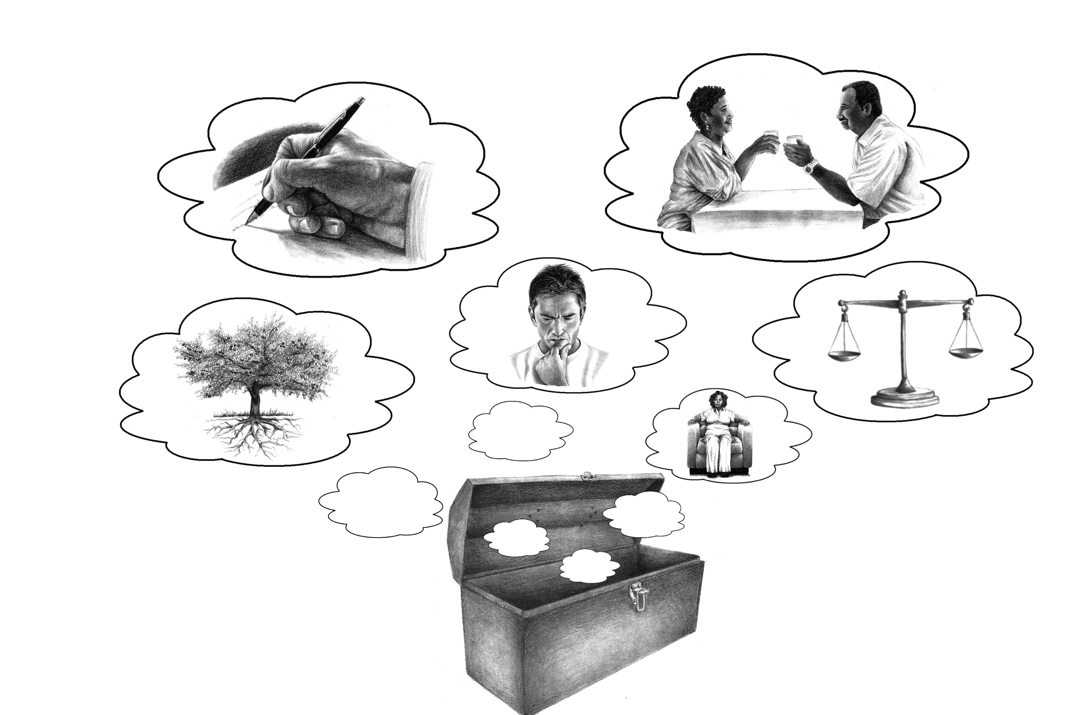
- Pain and Stress are related. Pain causes stress. Stress makes pain worse. Coping with stress in a good way makes pain
better.

- The way you think about or judge your stress affects what you
think, feel and do.
  - Is my stress a threat?
  - Is my stress a loss?
  - Is my stress a challenge?

- We learned a lot about how important our thoughts and beliefs are in shaping our emotions, the way our body feels, and our behavior. We learned how to catch ourselves having negative thoughts, how to weigh the evidence, and then how to come up with more realistic, positive, alternative thoughts and beliefs.

- Automatic Thoughts, Should Beliefs, and Core Beliefs affect the way
we cope with pain.
- We must be aware of our Automatic Thoughts, Should Beliefs, and
Core Beliefs in order to change them.
- Negative distorted Automatic Thoughts cause negative feelings,
behavior and more negative thoughts.
- Negative distorted Automatic Thoughts cause more pain and body aches.

- Most Negative Automatic Thoughts are partly true and partly not true.
- Looking at the evidence – the true and not true parts – of our
negative distorted Automatic Thoughts helps us create more
realistic and positive Alternative thoughts.
  - Thinking in more realistic and positive ways helps us to have
- More hopeful feelings and behavior
- Less pain and body aches
- Less stress
- Better sense of control over life

- Our Should Beliefs are rules we have for ourselves and others.
- Should beliefs can be negatively distorted.
- Looking at the evidence – the true and not true parts – of our
negative distorted beliefs helps us create alternative beliefs that
are more realistic and positive.

- Our Core Beliefs are deeply held beliefs or ideas we have had about
ourselves and the world since we were children.
  - Core Beliefs about ourselves as people in pain can have a strong
effect on how we cope.
- Changing our Core Belief from
I am a disabled chronic pain patient
to
I am a well person with pain is an important goal.

- A Coping Statement is a positive belief about you.
  - Coping statements give you an internal sense of control over you
and your pain. Coping statements increase your self-efficacy.

- Relaxation exercises focus on
- Breathing
- Relaxing your muscles
- Thinking in a calm way
- Paying attention to a peaceful word or a saying that makes you feel happy - a coping statement

- Strong feelings are part of coping with our chronic pain and stress. Expressing yourself by writing or talking about your feelings and thoughts
- Helps you understand your feelings and thoughts better
- Lowers your level of pain and body aches
- Creates feelings of control and happiness

- Assertive Communication helps you say exactly what you need and want in a direct and friendly way.
- Assertive Communication helps you remember that you have the right to ask for what you need and want. You have the right to say No when you do not want to do something.
- Assertive communication is not mean or selfish.
- Assertive communication helps improve your relationships.

- The new ideas and skills learned in this group must be practiced for you to get really good at them. The more you practice, the better you will be. The group is meant to get you started. Now your real work begins.

Give Feedback about Group Treatment
- What parts of the treatment program were most helpful?
- What parts of the treatment program did you struggle with or find most difficult?
- What parts of the program do you still have questions or concerns about?

Practice and Use New Ideas and Skills in Everyday Life
- You now have the tools to be your own counselor or therapist.
- Use your notebook often to read about the new ideas and skills you learned during the group classes.
- The more you practice and use these skills, the better you will feel and behave. These new skills will become a natural part of your life, and you will not have to think so hard about how to use them.

Expect Pain Flare-ups.
- Knowing there are times when the pain will be worse is better than worrying or being surprised about it.
- Coping with Pain Flare-ups
  - The most difficult time to use these new skills is during times when you have more pain.
  - The most important time to use these new skills is during times when you have more pain.
  - If you practice during the good times the new skills will be more easy to use during pain flare-ups.

Discussion
- What roadblocks do you think will get in your way of practicing these new skills?

Take-Home Daily Learning Activity
- Your Take-Home Daily Learning Activity is to use the tools in Your Thoughts Toolbox every day!

The Thoughts Toolbox

Remember the Stress and Coping Model of Pain - Pain is real. Pain and stress are related. Pain causes stress. Stress makes pain worse. Your thoughts about pain and stress affect your feelings, behavior, other thoughts, how you cope and even your physical well being.

Tool #1-How do you Judge your Stress? – a threat, a loss, or a challenge? How does your judgment affect your thoughts, feelings and how you deal with your stressful situation? When we break our stress into smaller parts, we have better control over the stressful situation. Try to judge some part of your stressful situation as a challenge.

Tool #2-Automatic Thoughts – Automatic Thoughts come up during times of stress or pain. We often become aware of Automatic Thoughts when our feelings change or we notice a change in our physical well being. With practice you can know your Automatic Thoughts by asking What just went through my mind? Negative and Distorted Automatic Thoughts can cause us more pain and stress. It is important to change negative and distorted Automatic Thoughts to manage your pain and stress better. You can change the negative and distorted part of your Automatic Thought by looking for the evidence – the true and not true parts. With practice you can change the negative distorted part of your Automatic Thought and create an Alternative Thought that is more realistic and positive.

Tool #3-Should Beliefs – Should Beliefs are rules we hold about ourselves, others and the world around us. We hold Should Beliefs about our pain, and how it should be treated. Should Beliefs are harder to change than Automatic Thoughts. With practice you can learn to 1) be aware of negative distorted beliefs, 2) look at the drawbacks and benefits of your distorted belief, and 3) create an alternative more realistic and positive belief.

Tool #4-Core Beliefs – Core Beliefs are deeply held ideas about ourselves and our worth. Core Beliefs are often related to thinking about yourself as a chronic pain patient, or disabled or ill. Building a more positive core belief system takes time. With practice you can learn to create an alternative core belief as a well person with pain. Remember that the acting as if activity is very helpful in creating Alternative Core Beliefs.

Tool #5-Relaxation – Relaxation exercises focus on breathing, relaxing your muscles, thinking in a calm way, and paying attention to a peaceful word or a saying that makes you feel happy – a coping statement. Practicing relaxation exercises every day helps you get good at the skill of relaxing your body and mind.
Tool #6-Coping Statements – Coping Statements are the cheerleaders in your thoughts toolbox! Coping statements lift your mood and help you feel more hopeful. Positive coping statements 1) increase your sense of control over at least some parts of your pain and 2) increase your power to cope in a healthy way. We make and read our coping statements to help us change those negative distorted automatic thoughts that come often. We write our coping statements onto Coping Cards and put them in places we will see often. It is a good idea to replace Coping Cards with new ones as our situation in life changes. Try using different 1) coping statements, 2) index card colors, and 3) places to put them.

Tool #7-Express Yourself Activity-Writing or talking about your deepest thoughts and feelings about your pain and other stressful situations in your life helps you understand them better. Writing or talking about strong feelings can make them seem less scary and out of control. Writing or talking is also a great way to get your feelings off your chest for a while. Use this tool when you feel like you need to vent, or when you are confused about or overwhelmed by your feelings. Remember to write or talk to yourself. Do not worry about spelling, grammar or cross outs. The Express Yourself activity is not for communicating with other people. It is for you and you alone!
Tool #8-Assertive Communication-We have wants and needs. We all have the right to express our wants and needs in a direct way without using excuses or saying we are sorry for asking. Assertive communication is a great tool to use when you want to share your feelings about something, ask for something, or say No. Practice assertive communication by planning out what you will say ahead of time. Your plan will increase your success in getting what you want and need. Assertive communication improves relationships, respects others, and helps you feel better about yourself. Remember to use I statements in assertive communication. Tell the other person about the problem in a simple and direct way. Then ask the person for what you need or want without using demanding or blaming words.



